Tracking Changes in Word
This is useful when 2 or more people are working on the same document and you want to be able to tell who has made which changes.
To start, click on the Review Tab.
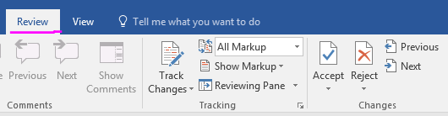
Choose “All Markup” or “Simple Markup”
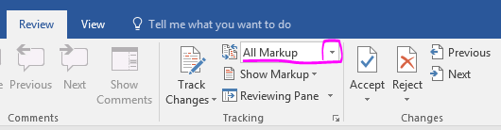
All Markup is very distracting because it shows every strikeout or change in format.
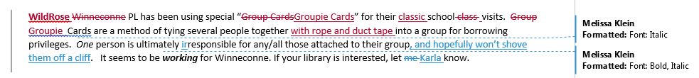
But it can be useful to see what was there before. So, you can switch between All Markup and Simple Markup as needed.
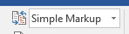
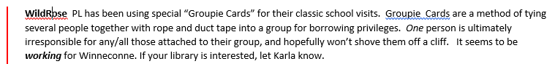

Eventually, one needs to decide which changes to Accept and which to Reject. You will want All Markup on for this.
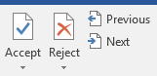
You can either click at the beginning of the document/paragraph and go through one at a time, or, my favorite, highlight and Accept the changes you want to keep, and then Reject all that remains.
Other helpful bits: If you want to see what’s been changed but don’t want All Markup on,
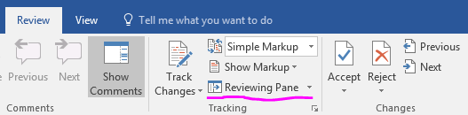
Turn the Reviewing Pane on. That lists all the revisions in a panel alongside the document
